

VILLAGE OF VIRGINIA GARDENS
6498 N.W. 38 TERRACE
VIRGINIA GARDENS, FLORIDA 33166
TELEPHONE: (305) 871-6104
FAX: (305) 871-1120

SPECIAL MEETING OF THE
PLANNING & ZONING BOARD
THURSDAY, APRIL 12, 2017
VILLAGE HALL – 6:30 P.M.

“Any person who decides to appeal any decision of the Village Council with respect to any matter considered at this meeting will need a record of the proceedings and, for such purpose, may need to insure that a verbatim record of the proceedings is made, which record includes the testimony and evidence upon which the appeal is to base.”

AGENDA
Call to Order

Approval of minutes

- Meeting of Nov. 14, 2017

Old Business

- None

New Business

- Annual selection of P&Z board chairperson

- Variance Request

ADDRESS OF PROPERTY:
5875 NW 36 STREET, VIRGINIA GARDENS, FL 33166
OWNER – POP FLORIDA PROPERTIES LLC FOLIO: 26-3025-001-0102

THE FOLLOWING VARIANCES HAVE BEEN REQUESTED BY POP FLORIDA PROPERTIES LLC WITH RESPECT TO CHAPTER 16 SECTION 7.1.4A OF THE VILLAGE OF VIRGINIA GARDENS CODE SO AS TO ALLOW FOR THE CONSTRUCTION OF ADDITIONAL SIGNAGE:

Section 7.1.4A - Variance to allow for 194.4 square feet for all business signage; where eighty (80) square feet is allowed, a difference of 114.4 square feet.

- Variance Request

ADDRESS OF PROPERTY:
3830 NW 62 AVENUE, VIRGINIA GARDENS, FL 33166
OWNER –FABIAN MARRERO & MARLENE RODRIGUEZ
FOLIO: 26-3025-001-0220

THE FOLLOWING VARIANCE HAS BEEN REQUESTED BY FABIAN MARRERO AND MARLENE RODRIGUEZ WITH RESPECT TO CHAPTER 16 SECTION 6.2.1, CHAPTER 16 SECTION 6.6.2-3, AND CHAPTER 16 SECTION 4.2.1(C) OF THE VILLAGE OF VIRGINIA GARDENS CODE SO AS TO ALLOW FOR A GARAGE CONVERSION AND AN ADDITION TO THE FRONT OF THEIR RESIDENCE.
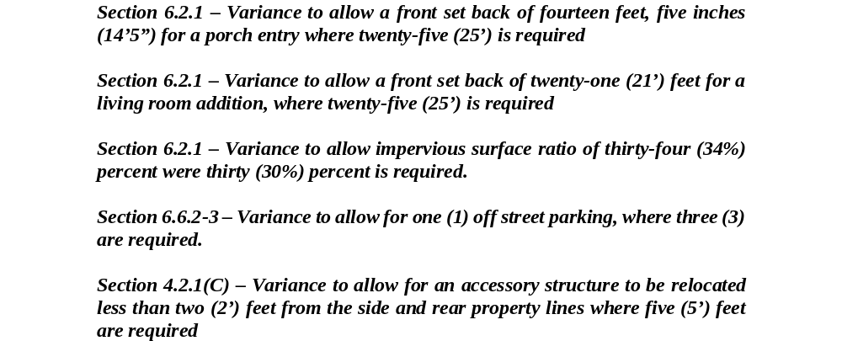

Good and Welfare

Adjournment

