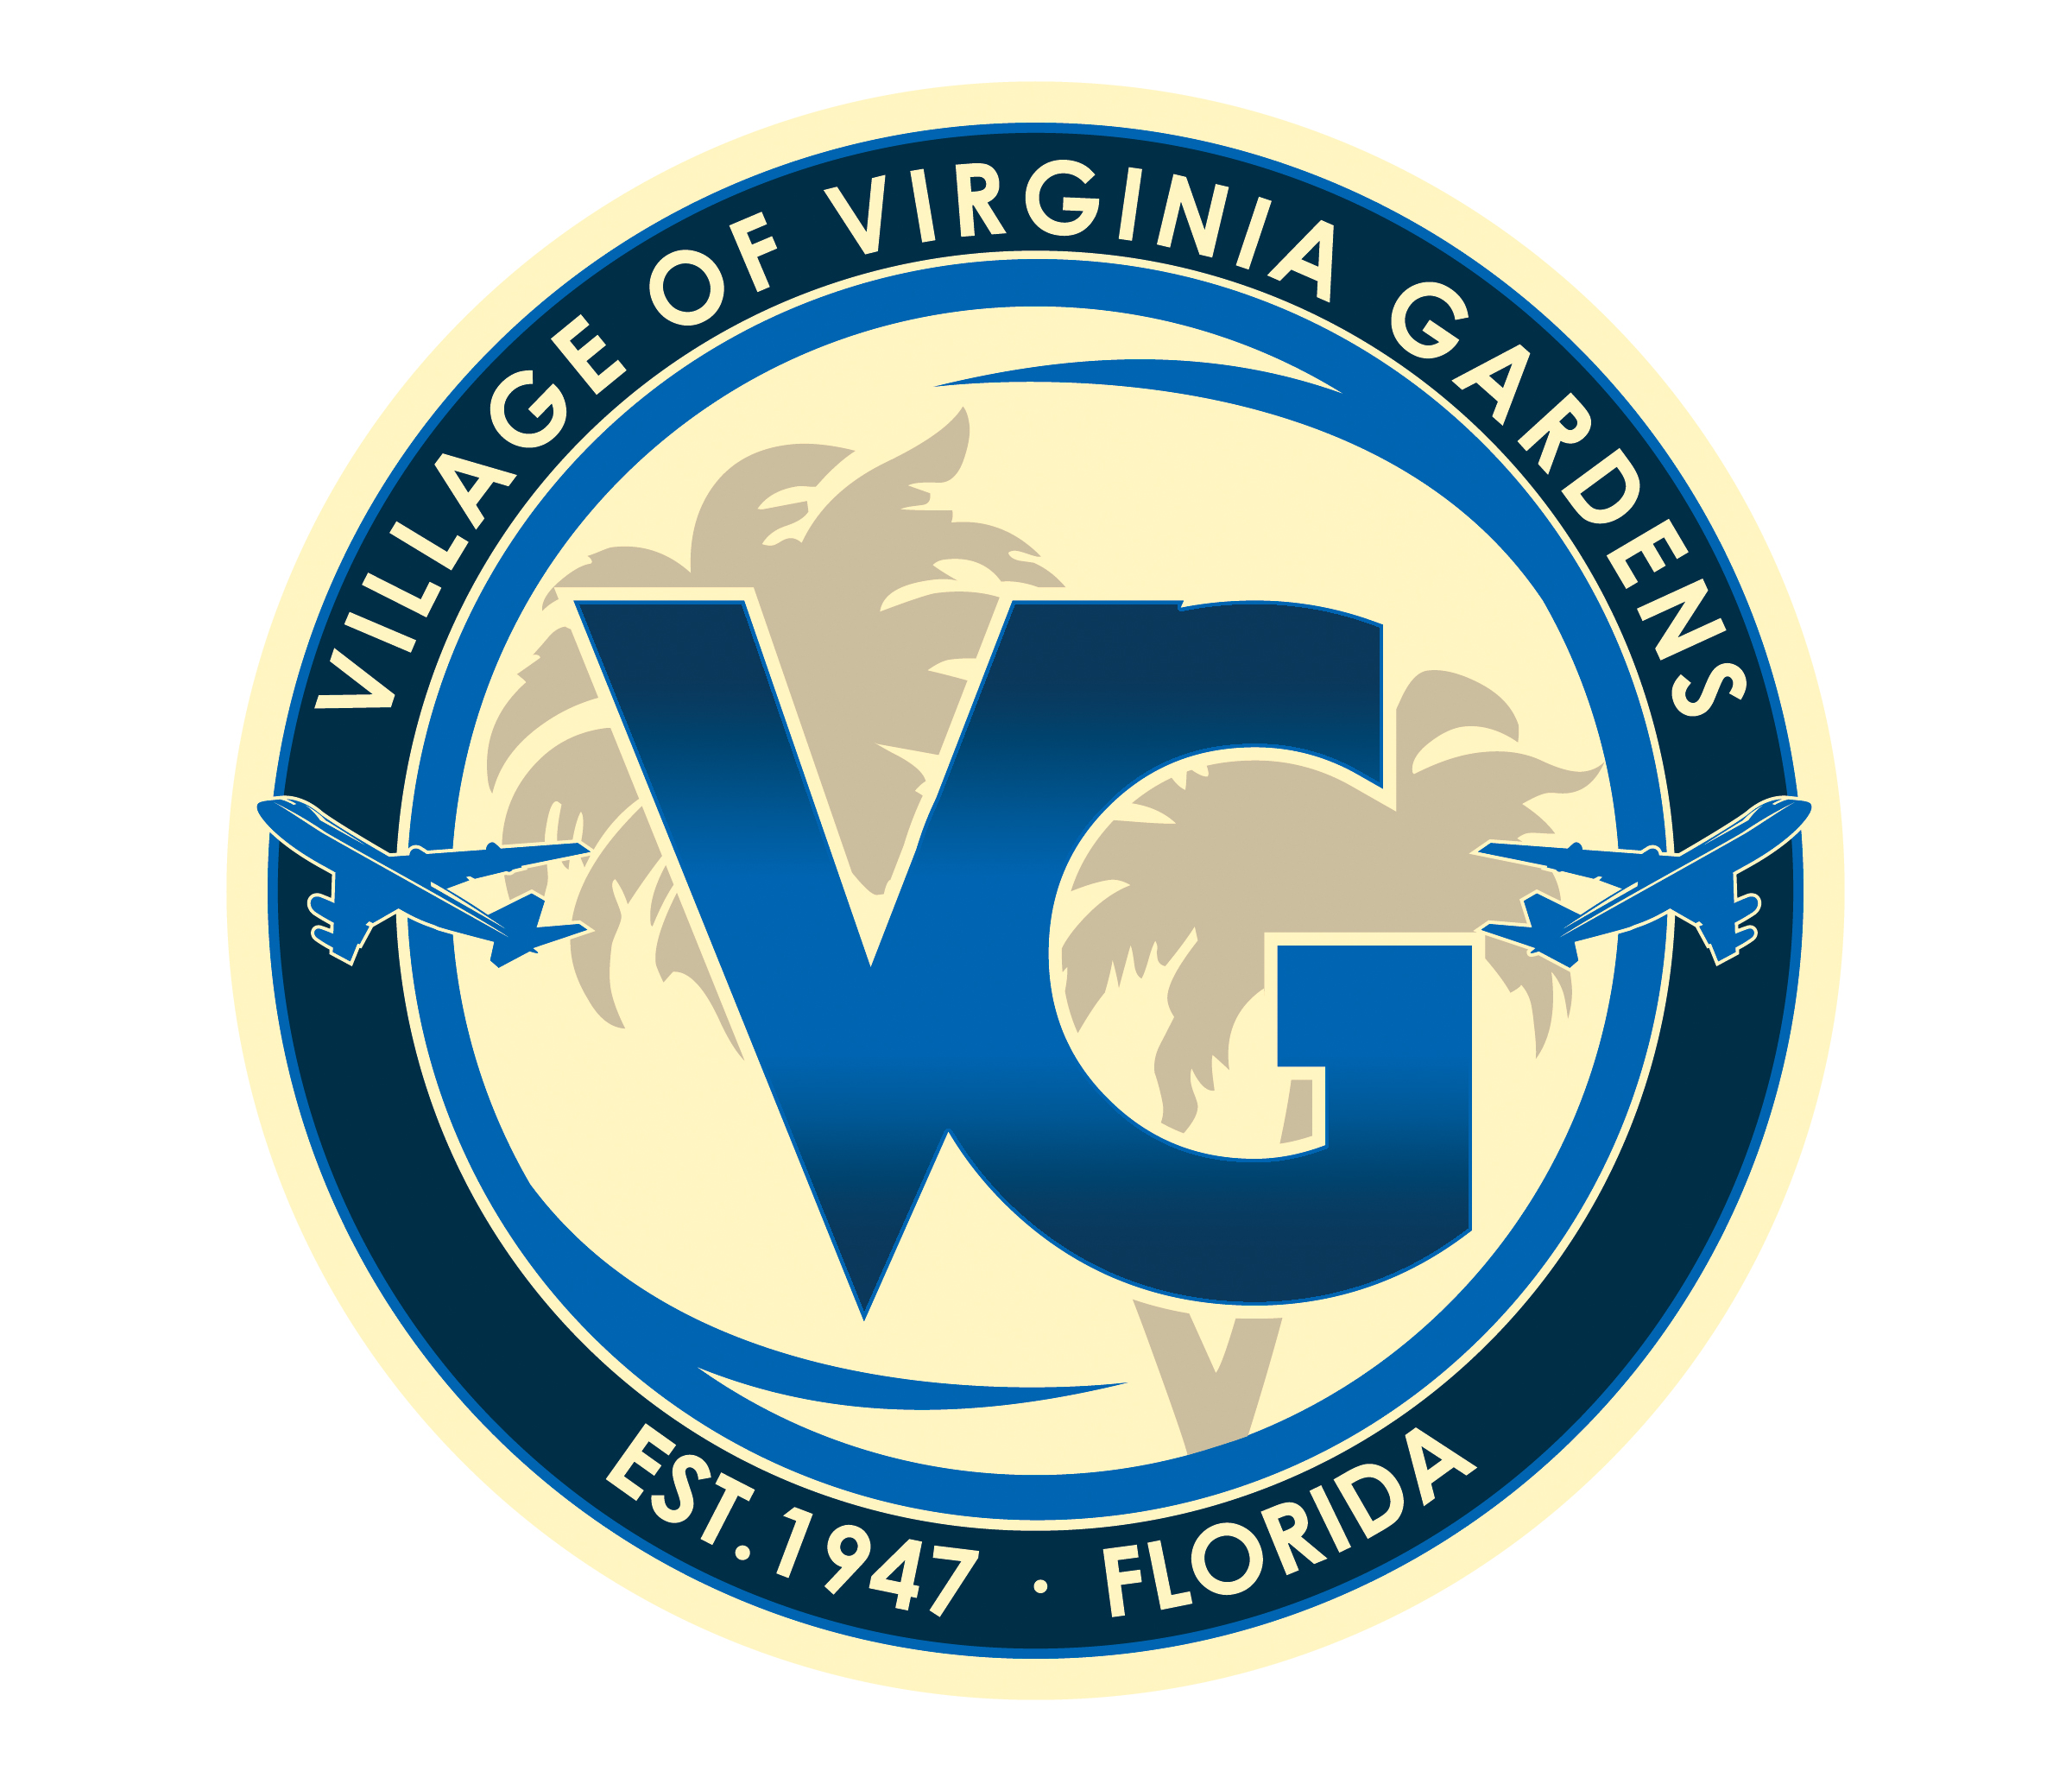

VILLAGE OF VIRGINIA GARDENS
6498 N.W. 38 TERRACE
VIRGINIA GARDENS, FLORIDA 33166
TELEPHONE: (305) 871-6104
FAX: (305) 871-1120

SPECIAL MEETING OF THE
PLANNING & ZONING BOARD
TUESDAY, NOV. 14, 2017
VILLAGE HALL – 6:30 P.M.

“Any person who decides to appeal any decision of the Village Council with respect to any matter considered at this meeting will need a record of the proceedings and, for such purpose, may need to insure that a verbatim record of the proceedings is made, which record includes the testimony and evidence upon which the appeal is to base.”

AGENDA
Call to Order

Approval of minutes

- Meeting of May 16, 2017

Old Business

- None

New Business

- Variance Request

ADDRESS OF PROPERTY:
5911 NW 36 STREET, VIRGINIA GARDENS, FL 33166
OWNER – WATERSTONE CAPITAL AIRPORT LLC
FOLIO: 26-3025-001-0261

THE FOLLOWING VARIANCES HAVE BEEN REQUESTED BY WATERSTONE CAPITAL AIRPORT LLC WITH RESPECT TO CHAPTER 16 SECTION 7.1.4A OF THE VILLAGE OF VIRGINIA GARDENS CODE SO AS TO ALLOW FOR THE CONSTRUCTION OF ADDITIONAL SIGNAGE:

Section 7.1.4A - Variance to allow for 357 square feet of signage for two(2) wall mounted signs and one(1) free standing monument sign; where eighty(80) square feet is allowed.

Good and Welfare

Adjournment

